COLLEGE OF ENGINEERING AND MANAGEMENT , KOLAGHAT

NAME: SANTU JANA

UNIVERSITY ROLL: 10700121127

COLLEGE ROLL:CSE/21/L-146

TITLE OF THE REPORT:

COMPARATIVE STUDY OF FCFS,SJF,SRTF,RR,AND PRIORITY SCHEDULING ALGORITHM

-: CONTENTS:-

1.INTRODUCTION

2.LITERATURE SURVEY

3.SYSTEM MODEL

4.DISCUSSION WITH DIAGRAMS/TABLES

6.CONCLUSION

5.REFERENCE

**I. INTRODUCTION**  
Scheduling is already part of a parallel process . In scheduling, there are several methods used to perform queue process that comes to the processor. Some algorithms are popular among other First Come First Serve, Shortest Job First, Round Robin,SRTF,and priority. In this study, The discussion involves the comparison of the average waiting time of each of these algorithms. The purpose of this comparison to determine what algorithm is more suitable for some processes that are in the ready queue. The priority of the processes that occur on the processor is something that determines when the process will be done. However, it does not discuss the priority inthis study. The scheduling assumes all of which occurred in the queue have the same priority value.  
***II. LITERATURE SURVEY:-***

The process is the state when a program is executed . When the computer is running, there are many processes running simultaneously. A process may create a derivative process is carried out by a parent process. The derivation process is also able to create a new process so that all of these processes ultimately forming process tree. When a process is made then the process can obtain these resources such as CPU time, memory, files, or I/O devices [2][4]. These resources can be obtained directly from the operating system, from the parent process that dispenses resources to each process its derivative, or the derivative and the parent process share the resources of a given operating system. CPU scheduling is part of a multi-programming operating system. Job scheduling is to move the CPU work among the processes. This serves to make the computer work more productive. A process generally consists of two cycles of Burst I/O and CPU Burst performed alternately until the process is complete

i) Scheduling Criteria:-There are different scheduling algorithms and performance of each can be judged on

various criterions. Different algorithms may favour different types of processes. Some criteria

are as follows:

1. CPU Utilization: Amount of time till CPU remains as busy as possible.

2.Throughput: Number of processes that complete their execution per unit time.

3. Burst Time: Amount of time required for the process for its execution.

4. Completion Time: The time when process completes its execution.

Turnaround Time: The time required to execute a particular process. It is denoted by:

5.Turnaround Time= Completion Time - Arrival Time (1)

6.Waiting Time: Amount of Time process was waiting in waiting queue. It is denoted by:

7.Waiting Time= Turnaround Time - Burst Time (2)

(i)***SJF(SHORTEST JOB FIRST):***

SJF algorithm is a special case of priority scheduling. Each process is equipped with a priority number that is burst time. The CPU is allocated to the process that has the highest priority (smallest integer value is usually the biggest priority). If several  
processes have the same priority, then it will use FCFS algorithm. Scheduling priority consists of two schemes, non-preemptive and preemptive. If there is a process P1 comes on when P0 is running, it will be a priority P1. Suppose P1 greater priority than the priority P0; then the non-preemptive, fixed algorithm will complete P0 to the end of its CPU burst, and put P1 in the head position  
in the queue. While in preemptive, P0 will be stopped first, and replace the CPU allocated to P1. Figure 2 shows the waiting time calculation of SJF.

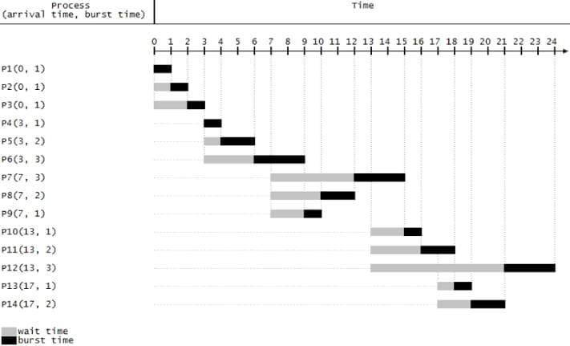

Fig. 1 Shortest Job First  
In Figure 1, the smallest burst time is 1. However, there are many processes which burst times are 1. Those processes are not in the same ready queue. The ready queue will be the same arrival time such as P1-P3, P4-P6 and so on. Let’s see the P7-P9; the smallest burst time is in P9 so that P9 will be performed first. However, in P4-P6, the FCFS is used.

**(ii)FCFS(FIRST COME FIRST SERVE):**

FCFS or FIFO can be defined as a process that arrives first will be served first. If there is a process to arrive at the same time, the services they carried through their order in the queue. The process in the queue behind had to wait until all the process front of him is complete. Any process that is on ready status put in FCFS queue according to the time of arrival. Figure 1 shows  
how the FCFS works.

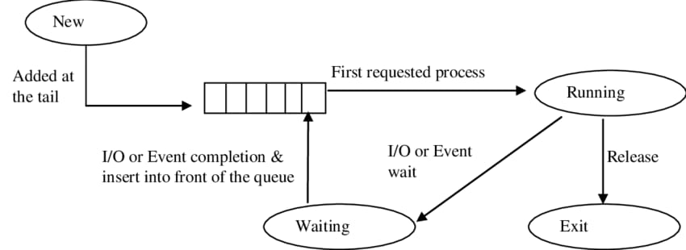

Fig 2: FCFS(FIRST COME FIRST SERVE)

The process which has been done does enter the queue anymore. However, here the process which burst time is short must wait for the other process to be finished.

**(iii)RR(ROUND ROBIN):**

In Round Robin concept, the algorithm uses time-sharing. The algorithm is same as FCFS, but it is preemted . Each process gets CPU time called a quantum time to limit the processing time, typically 1-100 milliseconds. After time runs out, the process is delayed and added to the ready queue. If a process has a CPU burst is smaller than the time quantum, then the process will release the CPU if it has finished its work so that the CPU can be immediately used by the next process[8][9]. Conversely, if a process has a CPU burst greater than the time quantum, the process will be suspended if it reaches a quantum of time, and then queuing back tothe position of the tail of the ready queue and then execute the next process. If there are n processes in the ready queue and the time quantum q, then each process of getting 1/n of the CPU time at most q time units at once CPU scheduling. No process waits for more than (n-1) q time units. Round Robin algorithm performance can be explained as the following figure when the queue is large,  
then the algorithm used is FCFS, but if the queue is small then frequent context switches is happening.

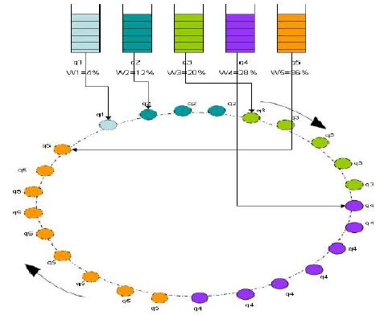

Fig 3:ROUND ROBIN

**(iv)PRIORITY SCHEDULING:**

Priority Scheduling is a method of scheduling processes that is based on priority. In this algorithm, the scheduler selects the tasks to work as per the priority.

The processes with higher priority should be carried out first, whereas jobs with equal priorities are carried out on a round-robin or FCFS basis. Priority depends upon memory requirements, time requirements, etc.

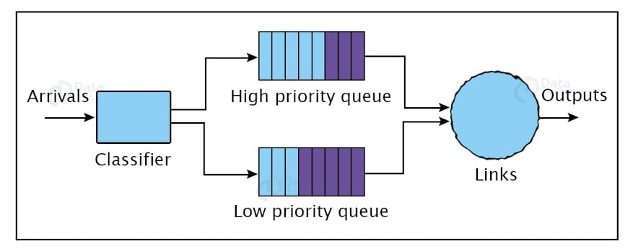

FIG 4:PRIORITY SCHEDULING

**(v)SRTF(Shortest Remaining Time First):**

This algorithm is based on SJF and this is the preemptive version of SJF. In this scheduling algorithm, the process with the smallest remaining burst time is executed first and it may be preempted with a new job that has arrived with a shorter execution time.

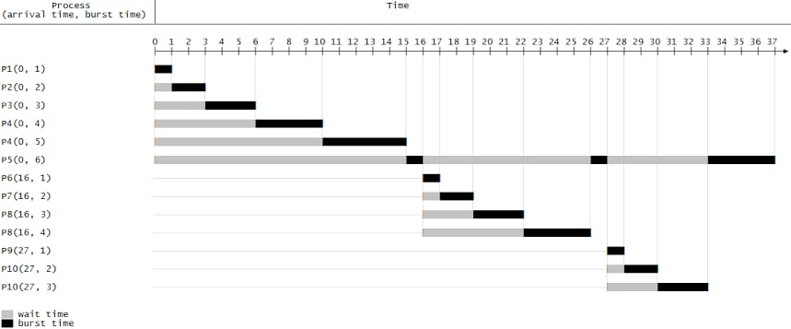

FIG 5: Shortest Remaining Time First

**(III)SYSTEM MODEL:**

The Purpose of a Scheduling algorithm

Here are the reasons for using a scheduling algorithm:

1.The CPU uses scheduling to improve its efficiency.

2.It helps you to allocate resources among competing processes.

3.The maximum utilization of CPU can be obtained with multi-programming.

4.The processes which are to be executed are in ready queue.

Summary:

1.CPU scheduling is a process of determining which process will own CPU for execution while another process is on hold.

2.In Preemptive Scheduling, the tasks are mostly assigned with their priorities.

3.In the Non-preemptive scheduling method, the CPU has been allocated to a specific process.

4.The burst time is the time required for the process to complete execution. It is also called running time.

5.CPU utilization is the main task in which the operating system needs to ensure that the CPU remains as busy as possible.

6.The number of processes that finish their execution per unit time is known Throughput.

7.Waiting time is an amount that a specific process needs to wait in the ready queue.

8.It is the amount of time in which the request was submitted until the first response is produced.

9.Turnaround time is the amount of time to execute a specific process.

TABLE 1:SCHEDULING DATA SET

|  |  |  |  |
| --- | --- | --- | --- |
| PROCESS | ARRIVAL TIME | PRIORITY | BURST TIME |
| P1 | 0 | 8 | 10 |
| P2 | 5 | 5 | 3 |
| P3 | 3 | 1 | 5 |
| P4 | 2 | 7 | 3 |

SJF:

|  |  |  |  |  |  |  |  |  |
| --- | --- | --- | --- | --- | --- | --- | --- | --- |
| P1 | P4 | P3 | P2 |  |  |  |  |  |

0 10 13 18 21

|  |  |  |  |
| --- | --- | --- | --- |
| PROCESS | CT | TAT(CT-AT) | WT |
| P1 | 10 | 10 | 0 |
| P2 | 13 | 8 | 5 |
| P3 | 16 | 13 | 8 |
| P4 | 21 | 19 | 16 |
|  |  | ATAT=50/4=12.5 | AWT=29/4=7.25 |

FCFS:

|  |  |  |  |  |  |  |  |  |
| --- | --- | --- | --- | --- | --- | --- | --- | --- |
| P1 | P2 | P3 | P4 |  |  |  |  |  |

0 10 13 18 21

|  |  |  |  |
| --- | --- | --- | --- |
| PROCESS | CT | TAT | WT |
| P1 | 10 | 10 | 0 |
| P2 | 13 | 8 | 5 |
| P3 | 18 | 15 | 10 |
| P4 | 21 | 19 | 16 |
|  |  | ATAT=13 | AWT=7.75 |

SRTF:

|  |  |  |  |  |  |  |  |  |
| --- | --- | --- | --- | --- | --- | --- | --- | --- |
| P1 | P4 | P2 | P3 | P1 |  |  |  |  |

0 2 5 8 13 21

|  |  |  |  |
| --- | --- | --- | --- |
| PROCESS | CT | TAT | WT |
| P1 | 21 | 21 | 11 |
| P2 | 8 | 3 | 0 |
| P3 | 13 | 10 | 5 |
| P4 | 3 | 1 | 2 |
|  |  | ATAT=8.75 | AWT=4.5 |

PRIORITY:

|  |  |  |  |  |  |  |  |  |
| --- | --- | --- | --- | --- | --- | --- | --- | --- |
| P1 | P4 | P3 | P2 | P4 | P1 |  |  |  |

0 2 3 8 11 13 21

|  |  |  |  |
| --- | --- | --- | --- |
| PROCESS | CT | TAT | WT |
| P1 | 21 | 21 | 11 |
| P2 | 11 | 6 | 3 |
| P3 | 8 | 5 | 0 |
| P4 | 13 | 11 | 8 |
|  |  | ATAT=10.75 | AWT=5.5 |

ROUND ROBIN: TABLE 2// RR SCHEDULING DATA SET

Q=30

|  |  |  |  |  |  |
| --- | --- | --- | --- | --- | --- |
| PROCESS | AT | BT | CT | TAT | WT |
| P1 | 0 | 72 | 112 | 112 | 40 |
| P2 | 50 | 10 | 70 | 20 | 10 |
| P3 | 60 | 84 | 252 | 192 | 108 |
| P4 | 70 | 30 | 142 | 72 | 42 |
| P5 | 100 | 56 | 228 | 128 | 72 |
|  |  |  |  | ATAT=104.8 | AWT=54.4 |

|  |  |  |  |  |  |  |  |  |  |
| --- | --- | --- | --- | --- | --- | --- | --- | --- | --- |
| P1 | P2 | P3 | P1 | P4 | P5 | P3 | P5 | P3 |  |

0 60 70 101 120 142 172 202 228 252

**IV.CONCLUSION**  
The calculation of three algorithms shows the different average waiting time. The FCFS is better for a small burst time. The SJF is better if the process comes to processor simultaneously. The last algorithm, Round Robin, is better to adjust the average waiting time desired. Round Robin quantum time will set it towards more SJF or FCFS value. All algorithm is good, but the speed of the process depends on the processor load.

**V.REFERENCES**  
[1] H. Heidari dan A. Chalechale, “Scheduling in Multiprocessor System Using Genetic Algorithm,” International Journal of  
Advanced Science and Technology, vol. 43, pp. 81-94, 2012.  
[2] C. Bajaj, A. Dogra dan G. Singh, “Review And Analysis Of Task Scheduling Algorithms,” International Research Journal  
of Engineering and Technology, vol. 2, no. 3, pp. 1449-1452, 2015.  
[3] N. Hamid, “Scheduling Policies,” [Online]. Available: <http://homepages.uel.ac.uk/u8902383/scheduling_policies.htm>.

© 2016 IJEDR | Volume 4, Issue 3 | ISSN: 2321-9939  
IJEDR1603022 International Journal of Engineering Development and Research (www.ijedr.org) 131  
[4] Arpaci-Dusseau, “Shortest Job Next,” 12 April 2016. [Online]. Available: https://en.wikipedia.org/wiki/Shortest_job_next.  
[Diakses 1 May 2016].  
[5] A. Dusseau, R. H. dan A. C., Operating Systems: Three Easy Pieces, Arpaci-Dusseau Books, 2014.  
[6] Tanenbaum, Modern Operating Systems, Pearson Education, Inc., 2008.  
[7] A. Noon, A. Kalakech dan S. Kadry, “A New Round Robin Based Scheduling Algorithm for Operating Systems: Dynamic  
Quantum Using the Mean Average,” IJCSI International Journal of Computer Science Issues, vol. 8, no. 3, pp. 224-229,  
2011.  
[8] I. S. Rajput dan D. Gupta, “A Priority based Round Robin CPU Scheduling Algorithm for Real Time Systems,” International  
Journal of Innovations in Engineering and Technology, vol. 1, no. 3, pp. 1-11, 2012.  
[9] R. Shyam dan S. K. Nandal, “Improved Mean Round Robin with Shortest Job First Scheduling,” International Journal of  
Advanced Research in Computer Science and Software Engineering, vol. 4, no. 7, pp. 170-179, 2014.